

Spring 2018 Newsletter www.tingeyadvisors.com 801-352-8166

Benchmarks

 | 31 Mar 2018 | 31 Dec 2017 | 31 Mar 2017
S&P 500 | 2,641 | 2,674 | 2,363
DJIA | 24,103 | 24,719 | 20,663
NASDAQ | 7,063 | 6,903 | 5,912
6-mo US Treasury Yield | 1.91% | 1.53% | 0.90%
30-yr US Treasury Yield | 2.97% | 2.74% | 3.01%
Prime Rate | 4.75% | 4.50% | 4.00%
Federal Funds Target Rate | 1.75% | 1.50% | 1.00%
30yr Mortgage | 4.54% | 3.99% | 4.13%
Gold – per oz | $1,330 | $1,303 | $1,250
Oil - WTI / bbl | $65 | $60 | $51
Source: WSJ, Bloomberg, Bankrate.com, Barrons, Zacks
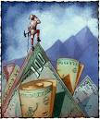

On Your Mark, Get Set … Hold!
Following an unusually strong 2017, serving up investors over 22% total return, the S&P 500 began 2018 with a full head of steam. On the heels of the new Tax Cuts and Jobs Act (TCJA) that materially lowered individual and corporate tax rates and created a major fiscal stimulus to the economy, investor euphoria spilled into January with no hint of diminishing. However, following its astonishing 5.6% return in January, the stock market hit a wall in February as yields on the 10-year U.S. Treasury note unexpectedly jumped above 2.9%. The rising rates caused fear of renewed inflation and precipitated an actual 3.9% decline for the month, which all but erased the positive return for the year.

If that weren’t enough to stop the bull in its tracks, President Trump tangled with China by lobbing tariff threats at one another. This set off a fear of global protectionism that could threaten already-complex supply channels and harm global trade and economic growth. While the tariff battle between China and the U.S. (involving products from steel to soybeans) amounts to less than 1% of either country’s economy, the psychological ripples could potentially slow the flow of goods throughout the world.
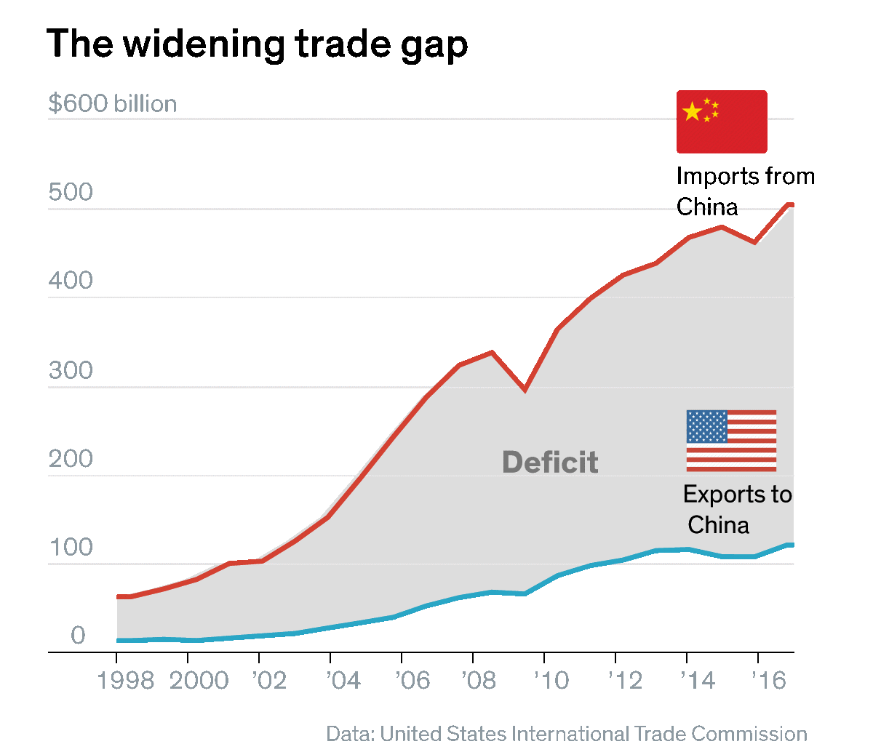
So far, the tariffs are small relative to the nearly $16 trillion worth of goods that flow between countries every year – nearly $4 trillion to and from the U.S. At this point, both countries have outlined tariffs of $50 billion to $100 billion with the threat of doubling those levels. If that were to occur, it would begin to lessen the economic growth of both countries – which we forecast to be about 3.0% in the U.S. this year. Trump’s “hard-nose” approach with China is motivated by his desire to reduce the U.S. trade deficit (imports vs. exports) for the longer-term health of our economy.
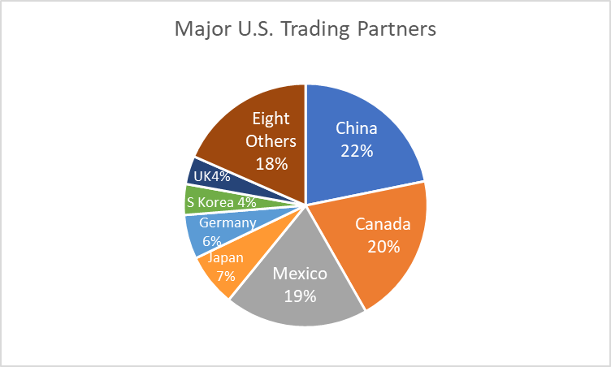
We currently view these tariff threats as political posturing intended to enhance negotiating power; but, as we suggested in our February Financial Markets Outlook, we see protectionism as the single biggest threat to the health of the financial markets. Therefore, we will continue to watch these developments closely, especially because they involve our largest trading partner.

Adding to the uncertainty of the first quarter, Janet Yellen, former Federal Reserve Chair, was replaced by Jay Powell. The Federal Reserve Chair is arguably the most influential force in the financial markets, and a transition of Fed Chair brings the uncertainty of potential policy change. Now with Chairman Powell in office for three months, we do not see any material change to current policy of slow, steady interest rate increases. March’s quarter-point increase in the fed funds rate to 1.75% should be matched twice more this year. We would not be surprised to see a continuation of this policy until short rates reach 2.5% - 3.0% in 2019. This should not, in itself, jeopardize a potential 3.0% GDP growth rate and above-average corporate earnings growth. The labor market remains strong (unemployment has dropped to 4.1%), consumer spending is firm and the economy is accelerating. Robust demand leaves the employment and supply chain resources struggling to keep up.

Stocks:
During the first quarter, two major changes became visible: 1) volatility increased materially following a calm 2017, and 2) the stock market’s upward trend was broken. While we believe increased volatility is with us for a season, we do not believe the market has entered a “bear market” phase. We believe the 10% correction we have just experience will be temporary. While stock prices have fallen, earnings expectations have risen. Hence, valuations (as defined by P/E ratios) have moderated. After trading above 19.1 times 2018 expected earnings of $150 (vs. $133 in 2017), the S&P 500 now trades at 17.8 times 2018 earnings and just 16.2 times expected 2019 earnings of $165. With interest rates at current levels and corporate profits rising, we do not believe the stock market is overvalued. We see strong corporate earnings with a backdrop of solid economic growth as the primary reason for optimism in the equity markets today.
Bond Market / Interest Rates:
Short-term interest rates continue their upward path. In their most recent meeting, the Fed lifted rates by a quarter-point; and will likely raise rates again twice more this year. If anything, the pace of rate increases may be quickened by the stimulus created by the tax bill and its potential effect on economic growth. Short rates will likely rise from 1.75% to 2.25% by year end, which should put upward pressure on the longer end of the yield curve as well. All told, we continue to emphasize short-term maturities with our fixed income strategy as we believe longer-term bonds have an embedded risk that is unattractive.

Inflation:
We continue to expect a slight acceleration in inflation during the year toward the Fed target of 2.0% (vs. 1.8% last year) driven by a tightening labor market and rising commodity prices. Oil, for example, continues its march to higher levels (now above $65 per barrel vs. $60 at year end). Rising crude prices are putting upward pricing pressure on downstream products such as gasoline and petro-chemicals used by consumers. Our forecast calls for a range-bound crude price around the $60 level due to the potential for quick supply increases from shale producers to meet expected demand. However, we recognize the potential scenario where total demand overwhelms supply and crude prices continue higher.

Risks and Uncertainties:
We see the following as the most significant risks near term: 1) protectionist risks represented by trade tensions with China, 2) a potential inflation scare that drives interest rates higher, 3) unintended consequences of the tax reform bill that create higher-than-expected federal deficits, and 4) an over-aggressive Federal Reserve that raises rates too quickly and damages the trend of above-average corporate earnings growth. We do not see economic recession as a viable scenario over the next twelve months, nor do we accept the arguments that we are heading into an imminent 2008-like financial recession.


Forecast
Increased market volatility, global political uncertainty, tax reform, U.S. corporate earnings, Federal Reserve interest rate strategy, and inflation are at center stage.

- Market volatility to continue.
After an unusually calm 2017, volatility has returned.
- Trade wars and other political maneuvering will affect the markets. While we are not forecasting a full-on global protectionist culture that could risk market stability, trade wars will add to market volatility in the near term.
- Tax reform sets the foundation for accelerated economic growth. However, it also presents the risk of higher federal deficits and ultimately high interest rates if economic growth does not accelerate as expected.
- Corporate earnings will accelerate. Following a solid growth of 7.5% in 2017, we believe corporate earnings growth will exceed 10.0% in 2018 under the current economic backdrop.
- Federal Reserve to continue tightening. Both through rate hikes (potentially two more in 2018) and by reducing the size of its balance sheet.
- Long bond returns struggle. We anticipate rising interest rates across the spectrum of the yield curve, however, the curve should continue to flatten. We desire to remain “short” with our fixed income strategy to avoid the upcoming pressure on long-term bond returns.
- Inflation moves higher. The current core CPI rate of 1.7% should move toward 2.0% during 2018.
- Business & consumer confidence continues to improve. The prospect of lower regulations and lower taxes will nudge economic growth upward – potentially above 3.0%
- Oil prices could surprise on the upside. While we have forecasted a sideways move this year, crude prices seem to have upward momentum. We continue to believe a bottom was set in 2016.
- U.S. Economic growth remains on a slow path to better. Economic growth and corporate profits should improve – we see no imminent sign of recession.
- Employment improves. The labor market will continue at historically low levels of unemployment.
- Stock market will be bumpy but will generate positive returns for 2018. We have experienced a correction, but we still believe returns for the year will be positive. Successful tax and regulation reform and continued strength in corporate profits should offer intermediate term opportunity.
- Our long-term forecast remains unchanged. We believe the stock market, while still subject to periodic corrections, is in an upward trend.

In Summary
We believe the economy is healthy and corporate profits are improving. As we have reiterated each quarter since the bear market of 2008, our investment strategies change with market conditions but our principles do not. Just as our principles have not changed, our long-term optimism remains in tact. We recognize that during times of uncertainty, communication is important. It is a pleasure doing business with you. We appreciate your confidence in us, especially during uncertain times.
Tingey Advisors, Inc., founded in 1996, is a registered investment advisor with the Securities and Exchange Commission. If you wish to receive the most recent copy of our ADV, please notify us. We invite you to visit our web page at www.tingeyadvisors.com or call us at (801) 352-8166. Any forward-looking statement mentioned above is subject to risk and uncertainty.

