

Winter 2019 Newsletter www.tingeyadvisors.com 801-352-8166

Benchmarks

 | 31 Dec 2018 | 30 Sep 2018 | 31 Dec 2017
S&P 500 | 2,507 | 2,914 | 2,674
DJIA | 23,327 | 26,458 | 24,719
NASDAQ | 6,635 | 8,046 | 6,903
6-mo US Treasury Yield | 2.51% | 2.36% | 1.53%
30-yr US Treasury Yield | 3.01% | 3.20% | 2.74%
Prime Rate | 5.50% | 5.25% | 4.50%
Federal Funds Target Rate | 2.50% | 2.25% | 1.50%
30yr Mortgage | 4.60% | 4.75% | 3.99%
Gold – per oz | $1,282 | $1,192 | $1,303
Oil - WTI / bbl | $46 | $75 | $60
Sources: WSJ, Barron’s, Zacks, Bloomberg
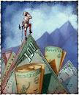

A Quarter to Forget!
The fourth quarter of 2018 punctuated a topsy-turvy year with three back-to-back weak months and a historically weak December. Stocks suffered a bruising stretch of selling as investors turned increasingly concerned about the health of the economy and the longevity of the decade-long bull market. Anxieties of continued weakness in global markets and their pain from a strong dollar coupled with domestic uncertainties transformed the tone of the market from positive to negative seemingly instantaneously. Fears of the U.S. economy softening and corporate profits collapsing were splattered in newspaper headlines and on the nightly news. China trade policy seemed to stoke fear of global protectionism. Global fears were compounded by our own domestic disputes that led to a partial government shut-down over the major political parties’ inability to address migration with any sense of unity.

Most significantly, in mid-December, the Federal Reserve announced another 0.25% increase in short-term interest rates and further proclaimed that 2019 would likely see two more increases. The stock market reacted swiftly and decisively by driving stock prices violently downward, signaling its vote that the economy was not strong enough to take that level of medicine.

Stocks:
The year 2018 was not kind to the equity markets as the S&P 500, Dow Jones Industrial Average and NASDAQ declined 6.2%, 5.6% and 3.9%, respectively. These returns represented the worst yearly performance since the Great Recession of 2008 and encouraged many investors to begin drawing comparisons.

The declines in U.S. equities were surpassed by drops in overseas markets. For the year, the U.K.’s FTSE 100 declined 13.0% as did the Stoxx Europe 600 index. Japan’s Nikkei Stock Average fell 12.0%, the Shanghai Composite finished down 25.0% and Hong Kong’s Hang Seng lost 14.0%. Clearly, the contagion spread worldwide.

Here at home, the year ended on a down note as the S&P 500 was in the red 14.0% during the fourth quarter, with the Dow Jones Industrial Average down 11.8% and the tech-heavy NASDAQ down 17.5%.

Bonds / Interest Rates:
The Federal Reserve has clearly moved from dovish to hawkish over the past year as they have relentlessly driven rates higher in the face of seemingly non-existent inflation. The financial markets reacted in December as if the Fed was using a bazooka gun to hunt pheasants. We agree that the Fed errored in its overreach by broadcasting further increases when we have now reached apparent equilibrium. The long bond – post Fed decision – rallied strongly (driving rates lower) as a sign the market feels the Fed may be pushing the economy into recession. The current flat yield curve shown below reflects such fears.
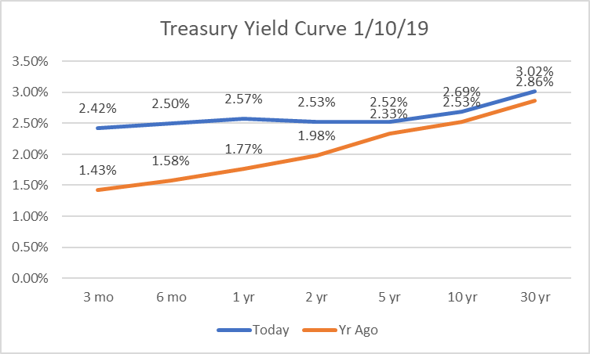
As the new year began, the Fed perceived the market volatility it had created and made an attempt to clarify its stance in early January by pulling back from its position of future increases. The verbal “correction” was welcomed by the financial markets and has, of late, introduced a sense of calm. Going forward, we believe the economy is still on firm footing as long as the Fed backs off of its aggressive stance.

U.S. Dollar:
The U.S. dollar was relentlessly strong in 2018, rising 4.3% against its basket of 16 other major currencies – the strongest performance worldwide – driven largely by the four rate increases by the Federal Reserve. In addition to negatively affecting foreign markets whose dollar-denominated debt became more difficult to service, it also affected: 1) U.S. multinational exporters who must convert foreign profits into dollars, and 2) U.S. exporters who lose competitive advantage as their products become more expensive to the world at large.
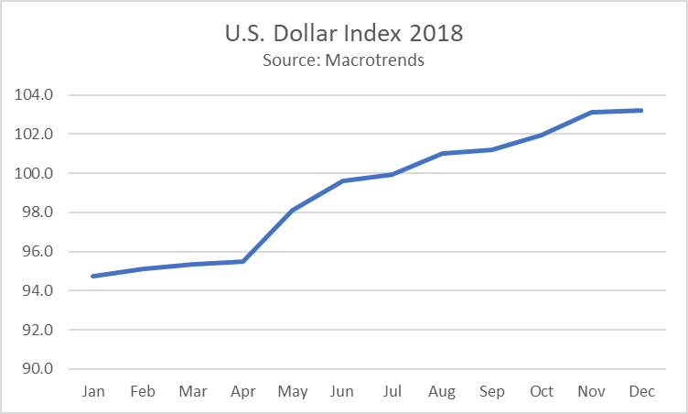
While the U.S. Dollar’s advance in 2018 created significant headwinds for U.S. stocks, there are signs the wind is fading as the Federal Reserve is adopting a new wait-and-see approach. The dollar is likely to continue to be strong until the market receives better signals about Fed Policy and/or future economic growth.

Risks and Opportunities:
We see the following as the most significant near-term risks: 1) Federal Reserve policy that drives rates too high and jeopardizes economic growth, 2) unusual political infighting domestically, 3) potential increase in inflation due to the effect of tight labor markets on wages, 4) decelerating corporate profit growth, and 5) global debt and a rising potential for default among weaker nations causing a global ripple effect.

We see the following as the most significant opportunities near term: 1) solid economic growth, 2) contained inflation, 3) growing corporate profits, 4) consumer and corporate optimism, 4) solid labor market and improving consumer financial health, 5) progress in global trade agreements, 6) no signs of imminent recession in the U.S.

Economic expansions don’t die of old age; rather, they either conclude because of financial bubbles and imbalances or they end due to the Federal Reserve implementing overly-restrictive policy. Our view is that the economy is strong but is at risk of an overly-aggressive Federal Reserve. While we are cautious, at this stage we continue to see opportunities outweighing risks.

Forecast
Continued positive fundamentals with increased market volatility. Trade tensions and other global and domestic political uncertainty, tax reform, U.S. corporate earnings, Federal Reserve interest rate strategy, and inflation are at center stage.

- Market volatility to continue.
After an unusually calm 2017, volatility returned in early 2018 and will likely continue.
- Trade tensions to affect the markets. With the success of UMCSA (the new NAFTA) last year and talk of progress in the China trade talks, we believe all-out protectionism will be avoided and this may be a variable that creates upside in the market.
- Tax reform affects subsiding. With one year of new tax law behind us, we may be in for a declining positive stimulus from tax reform going forward. However, the benefits of lower taxes should have a long tail both in consumer spending, capital spending and corporate profits. Our concern relates to the risk of higher federal deficits and ultimately higher interest rates if economic growth stalls.
- Corporate earnings to decelerate following record 2018 growth rates. Following a year of dramatic corporate profit growth, we believe corporate earnings will continue to grow from a higher base created by the new tax law.
- Federal Reserve to continue tightening. Following the Federal Reserve’s 0.25% increase in December and the negative response by the stock market, we see the Fed pausing temporarily before implementing changes to monetary policy.
- Long bond returns struggle. We anticipate rising interest rates across the spectrum of the yield curve. We desire to remain “short” with our fixed income strategy to avoid the upcoming pressure on long-term bond returns.
- Inflation moves higher. Inflation has remained surprisingly calm. We anticipate some slight nudging upward in inflation during 2019 due to the tight labor market.
- Business & consumer confidence remains high. The prospect of lower regulations and lower taxes should keep business & consumer confidence high.
- Oil prices could surprise on the upside. After a sharp year-end decline, oil prices should move higher over the coming months. We continue to believe a bottom was set in 2016.
- U.S. Economic growth continues. Economic growth and corporate profits should improve – we see no imminent sign of recession.
- Employment continues strong. The labor market will continue to produce historically low levels of unemployment and the labor force will increase.
- Stock market will be bumpy but will generate positive returns for 2019 following a negative 2018. The unusually weak fourth quarter last year should set the foundation for stabilization followed by recovery in 2019. We see positive returns ahead.
- Our long-term forecast remains unchanged. We believe the stock market, while still subject to periodic corrections, is in an upward trend.

In Summary

We believe the economy is healthy and corporate profits are improving. As we have reiterated each quarter since the bear market of 2008, our investment strategies change with market conditions but our principles do not. Just as our principles have not changed, our long-term optimism remains in tact. We recognize that during times of uncertainty, communication is important. It is a pleasure doing business with you. We appreciate your confidence in us, especially during uncertain times.
Tingey Advisors, Inc., founded in 1996, is a registered investment advisor with the Securities and Exchange Commission. If you wish to receive the most recent copy of our ADV, please notify us. We invite you to visit our web page at www.tingeyadvisors.com or call us at (801) 352-8166. Any forward-looking statement mentioned above is subject to risk and uncertainty.

