

Spring 2019 Newsletter www.tingeyadvisors.com 801-352-8166

Benchmarks

 | 31 Mar 2019 | 31 Dec 2018 | 31 Mar 2018
S&P 500 | 2,834 | 2,507 | 2,641
DJIA | 25,929 | 23,327 | 24,103
NASDAQ | 7,729 | 6,635 | 7,063
6-mo US Treasury Yield | 2.43% | 2.51% | 1.91%
30-yr US Treasury Yield | 3.85% | 3.01% | 2.97%
Prime Rate | 5.50% | 5.50% | 4.75%
Federal Funds Target Rate | 2.50% | 2.50% | 1.75%
30yr Mortgage | 4.19% | 4.60% | 4.54%
Gold – per oz | $1,299 | $1,282 | $1,330
Oil - WTI / bbl | $60 | $46 | $65
Sources: WSJ, Barron’s, Bloomberg
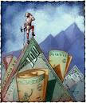

Rebound!
What a difference three months make! One quarter ago, we were “licking our wounds” following a historically weak fourth quarter caused by global economic fears, domestic political disputes and an overly-aggressive Federal Reserve bent on driving interest rates higher. Three months later, the stock market has just delivered the strongest performance of any quarter since 2009. The volatility of the last six months has been driven by emotional crosscurrents, which accentuates the value of keeping a “steady hand on the plow.” Those investors who succumbed to the emotions of December and fled equities missed one of the most significant rebounds on record. All-in-all, investors are putting more money into U.S. stocks as the 2019 rebound continues.

In our view, several noteworthy developments occurred in the first quarter that propelled the stock market forward: 1) the Federal Reserve, recognizing its potential miscalculation, backed away from its pronouncement in December of two additional rate hikes in 2019, 2) the partial government shutdown ended in January, 3) investors became increasingly convinced that U.S.-China trade talks will succeed, stabilizing the world economy and boosting corporate earnings, 4) the domestic economy slowed, but remains firm with no visible sign of recession, and 5) resolution of a two-year investigation of the current administration removed a degree of political uncertainty. Furthermore, robust corporate share buybacks have helped build a floor for stocks. Share repurchases among S&P 500 companies totaled $223 billion in the fourth quarter, a 63% increase year-over-year and a vote of confidence by corporate management. Through share repurchases, corporate earnings per share appear stronger as shares outstanding are retired, but repurchases generally accompany a positive, confident outlook by management and strong corporate cash flow.

The most recent index of manufacturing activity published by the U.S. Institute of Supply Management underlines the continuing strength of the U.S. economy. The index is based on whether manufacturing supply managers see activity at their companies expanding or contracting. Numbers above 50 suggest expansion while numbers below 50 represent contraction. The fall from August to November last year coincided with fears of recession and market weakness. More recently, the rise in March to 55.3 suggests a stabilizing trend and indicates continued expansion.

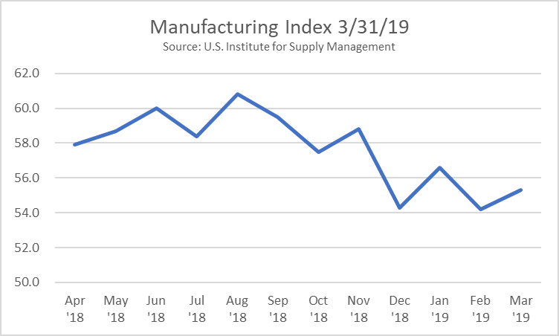

Though manufacturing alone is a small part of the total Gross Domestic Product (the “economy”), it is highly cyclical and serves as a harbinger of future economic activity. It is also noteworthy that China has mirrored the U.S.’s recent manufacturing strength in their own economy, in spite of the on-going trade dispute.

Stocks:
Performance among most indexes of the market was unusually strong in the 1st quarter of 2019 as the S&P 500, Dow Jones Industrial and NASDAQ were up 13.0%, 11.2% and 16.5%, respectively. Foreign markets, with the exception of Europe, were also firmer as fears of a global recession, that surfaced at the end of last year, subsided. This, in spite of the expectation that S&P 500 companies will likely report a 4% decline in 1st quarter profits - their first decline in year-over-year quarterly profits since 2016. However, as we reported in our Financial Markets Outlook in February, when adjusted for last year’s one-time benefit from the 2017 tax reform act, 1st quarter 2019 earnings should actually be higher than last year. As we enter the 1st quarter earnings announcement season, our eyes will be fixed on the strength and trends of corporate earnings; but at this point, we see nothing that jeopardizes our positive outlook for the stock market.

Bonds / Interest Rates:
The bond market rallied strongly during the quarter, sending rates lower. Short rates remained relatively firm, but rates in the middle and long sections of the Treasury yield curve dropped materially. The curve, which is normally upward sloping, flattened because of market expectations (see below) and even became slightly inverted at the end of the quarter as the 10-year rate was trading below the 3-month rate for a short period of time.
Often, an “inverted yield curve” signifies possible recession, which would have negative implications for the stock market as economic recessions pressure corporate profits. However, under current conditions, we expect the inverted yield curve to “correct itself” near term and return to an upward sloping curve without experiencing recession. We continue to believe that purchasing bonds on the short end of the curve makes sense. While inverted yield curves are significant signals, they are imprecise with respect to timing. Historically, the economy falters somewhere between 9 months and 5 years from the time of an inverted yield curve. The last inverted yield curve was in 2007 and accurately signaled the impending recession. However, while recession ultimately came, the stock market moved 29% higher from the time the yield curve inverted until the stock market peaked.

Risks and Opportunities:
We see the following as the most significant near-term risks: 1) a prolonged dispute between the U.S. and China that leads to harmful protectionism and negatively impacts the global economy, 2) a potential increase in inflation due to the effect of tight labor markets on wages, 3) decelerating corporate profit growth that could become more pronounced than we anticipate, 4) global debt and a rising potential for default among weaker nations causing a global ripple effect, and 5) wider government policy swings from a polarized government.

We see the following as potential opportunities near term: 1) solid economic growth, 2) contained inflation, 3) corporate profits potentially better than the market expects, 4) consumer and corporate optimism, 5) solid labor market and improving consumer financial health, 6) progress in global trade agreements.

The Federal Reserve implementing a less-restrictive policy is a positive. Our view is that the economy can remain strong if the Fed does not become overly-aggressive. While we are cautious, at this stage we continue to see opportunities outweighing risks.

Forecast
Continued positive fundamentals with increased market volatility. Trade tensions and other global and domestic political uncertainty, tax reform, U.S. corporate earnings, Federal Reserve interest rate strategy, and inflation are at center stage.

- Market volatility to continue.
After an unusually volatile 4th quarter, the 1st quarter ushered in a relative calm. However, we see volatility continuing.
- Trade tensions to affect the markets. With the success of UMCSA (the new NAFTA) last year and talk of progress in the China trade talks, we believe all-out protectionism will be avoided and this may be a variable that creates upside in the market.
- Tax reform affects subsiding. With one year of new tax law behind us, we may be in for a declining positive stimulus from tax reform going forward. However, the benefits of lower taxes should have a long tail both in consumer spending, capital spending and corporate profits. Our concern relates to the risk of higher federal deficits and ultimately higher interest rates if economic growth stalls.
- Corporate earnings to decelerate following record 2018 growth rates. Following a year of dramatic corporate profit growth, we believe corporate earnings will continue to grow from a higher base created by the new tax law.
- Federal Reserve to pause. Following the Federal Reserve’s 0.25% increase in December and the negative response by the stock market, we see the Fed pausing temporarily before implementing changes to monetary policy.
- Long bond returns struggle. We anticipate rising interest rates across the spectrum of the yield curve following falling rates in the first quarter. We desire to remain “short” with our fixed income strategy to avoid the upcoming pressure on long-term bond returns.
- Inflation moves higher. Inflation has remained surprisingly calm. We anticipate some slight nudging upward in inflation during 2019 due to the tight labor market.
- Business & consumer confidence remains high. The prospect of lower regulations and lower taxes should keep business & consumer confidence high.
- Oil prices could surprise on the upside. After a sharp year-end decline, oil prices should move higher over the coming months. We continue to believe a bottom was set in 2016.
- U.S. Economic growth continues. Economic growth and corporate profits should improve – we see no imminent sign of recession.
- Employment continues strong. The labor market will continue to produce historically low levels of unemployment and the labor force participation will increase.
- Stock market will be bumpy but will generate positive returns for 2019 following a negative 2018. The unusually weak fourth quarter last year should set the foundation for stabilization followed by recovery in 2019. We see positive returns ahead.
- Our long-term forecast remains unchanged. We believe the stock market, while still subject to periodic corrections, is in an upward trend.

In Summary

We believe the economy is healthy and corporate profits are growing. As we have reiterated each quarter since the bear market of 2008, our investment strategies change with market conditions but our principles do not. Just as our principles have not changed, our long-term optimism remains in tact. We recognize that during times of uncertainty, communication is important. It is a pleasure doing business with you. We appreciate your confidence in us, especially during uncertain times.
Tingey Advisors, Inc., founded in 1996, is a registered investment advisor with the Securities and Exchange Commission. If you wish to receive the most recent copy of our ADV, please notify us. We invite you to visit our web page at www.tingeyadvisors.com or call us at (801) 352-8166. Any forward-looking statement mentioned above is subject to risk and uncertainty.

