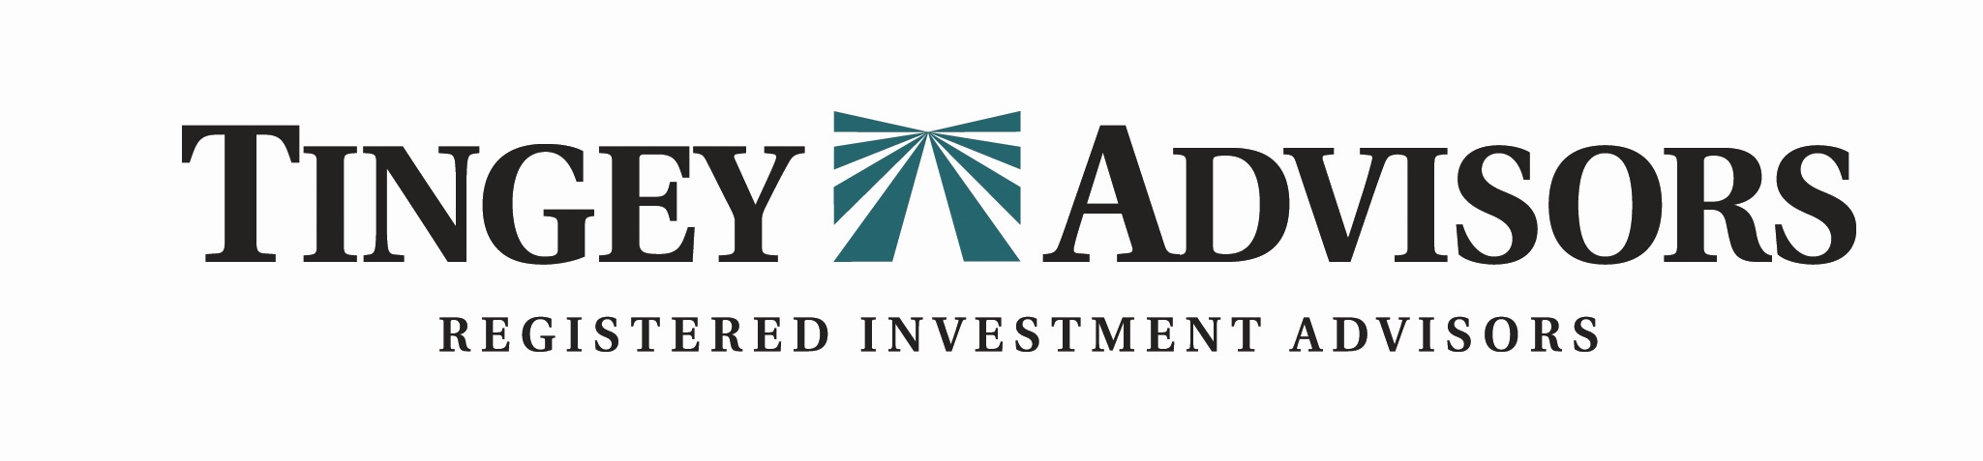

Summer 2019 Newsletter www.tingeyadvisors.com 801-352-8166

Benchmarks

 | 30 June 2019 | 31 Mar 2019 | 30 June 2018
S&P 500 | 2,942 | 2,834 | 2,718
DJIA | 26,600 | 25,929 | 24,271
NASDAQ | 8,006 | 7,729 | 7,710
6-mo US Treasury Yield | 2.09% | 2.43% | 2.15%
30-yr US Treasury Yield | 2.52% | 3.85% | 3.8%
Prime Rate | 5.50% | 5.50% | 5.00%
Federal Funds Target Rate | 2.50% | 2.50% | 2.00%
30yr Mortgage | 3.90% | 4.19% | 4.52%
Gold – per oz | $1,409 | $1,299 | $1,251
Oil - WTI / bbl | $58 | $60 | $74
Sources: WSJ, Barron’s, Bloomberg, Economist, NBER, Blackrock
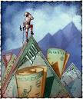

Economy Sets a Record
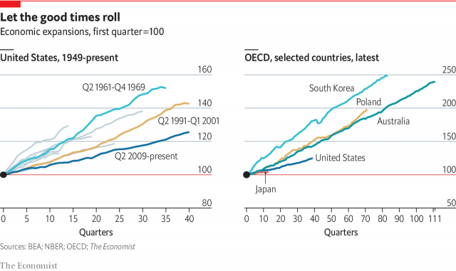
The economic expansion experienced by the United States since 2009 is now the longest on record. While that, in and of itself, is worthy of celebration, the cumulative expansion has nevertheless been disappointingly weak. The economic expansion that began June 2009 has grown uninterrupted for 40 consecutive quarters, (ten years) making it the longest expansion on record according to the National Bureau of Economic Research (NBER). The previous record was a nearly ten-year boom that took place from 1991 to 2001.
While the current expansion is setting records for longevity it is not setting records for growth. The current expansion has been positive but it would be hard to categorize it as a boom – but we’ll take it! According to NBER, during the current ten-year expansion our economy has grown about 25% in total; whereas with the prior ten-year expansion we experienced in the 1990’s the total growth of the economy was about 42%.

Over time the business cycle has been extending. The four decades after World War II, economic expansions lasted, on average, three years and eight months. Since 1981, they have stretched out to more than eight years on average. Our sense is that the productivity generated by the technology wave since 1981 has helped companies manage their inventories much better, thus smoothing and lengthening out the business cycles.

Former Federal Reserve Chairwoman Yellen declared at the first of the year that, “I don’t think expansions die of old age.” We’d agree. Expansions usually don’t die of old age. They get shot, by ill-advised government policies.

The stock market has responded to the extended economic growth and is flirting with record highs again. The historically weak end to 2018 seems long in the rear-view mirror, yet some of the same concerns prevail as the stock market has climbed the proverbial ‘wall of worry’ through the first half of the year. These investors’ ‘worries’ have been centered on global economic fears, domestic political disputes and an overly-aggressive Federal Reserve.

Stocks:
The stock market is again at record levels propelled by optimistic investor expectations that the U.S. and China will come to some resolution on the trade dispute, and that the Federal Reserve will change directions and begin to lower short term interest rates.

The S&P 500 index, Dow Jones Industrial Average and Nasdaq Composite advanced 4.3%, 3.2% and 4.2 % respectively, in the quarter. This strong second quarter performance is on the heels of a very robust Q1. The market responded to strong Q1 corporate earnings, hopes for resolution on the China trade dispute and prospects of lower interest rates.

Year-to-date, the S&P 500, Dow Jones Industrial Average, and Nasdaq Composite are up an impressive 18.5% 15.4% and 21.6% respectively. Notably, the small-cap Russell 2000 is up strongly at 17.0% but has lagged mid-cap and large-cap indices. The strongest U.S. sectors in the quarter were consumer services, financials and industrials. Year-to-date, the strongest U.S. sectors have been technology, industrials and consumer services. Relative to foreign markets the U.S. stock market held up very well.

Year-to-date, the MSCI EAFE index has risen 13.8%. The MSCI Europe index grew 15.8% and the MSCI emerging markets gained 10.6%. Interestingly, the quarter end was punctuated by two mega merger/acquisition announcements. Abbvie Inc. announced they would purchase Allergan PLC for $63 Billion and United Technologies announced an $86 Billion merger with Raytheon Co.

Bonds / Interest Rates:
While the stock market ended the quarter on an optimistic note, the bond market was singing a different tune. Safety seeking investors drove intermediate to long term rates lower.

Short rates remained relatively firm, due to the Federal Reserve’s 2018 rate increases. Yet, the long bond (30-year Treasury Bond) fell a remarkable 133 basis points in the quarter dropping from 3.85% to 2.52%. The two-year Treasury Bond also dropped from 2.43% to 2.09%. With yields on short-term rates staying firm and yields on other bond maturities dropping, the result was that for much of the quarter the yield curve was flat to inverted. Often, an inverted yield curve (where short-term rates are higher than longer term rates) signals possible recession.
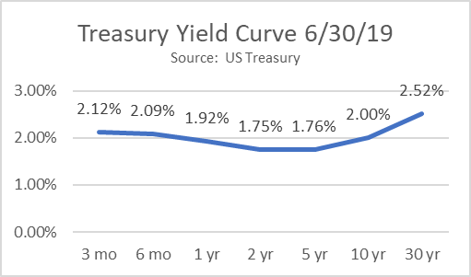
The current debate in the capital markets is whether the yield curve inverted due to underlying economic realities, or whether the yield curve inverted because of an overly ambitious Federal Reserve that can reverse their stance and become more accommodative.

Risks and Opportunities:
We continue to see the following as the most significant near-term risks: 1) a prolonged dispute between the U.S. and China that leads to harmful protectionism and negatively impacts the global economy, 2) a potential increase in inflation due to the effect of tight labor markets on wages, 3) decelerating corporate profit growth that could become more pronounced than we anticipate, 4) global debt and a rising potential for default among weaker nations causing a global ripple effect, and 5) wider government policy swings from a polarized government.

We see the following as potential opportunities near term: 1) solid economic growth, 2) contained inflation, 3) corporate profits potentially better than the market expects, 4) consumer and corporate optimism, 5) solid labor market and improving consumer financial health, 6) progress in global trade agreements,
7) The Federal Reserve implementing a less-restrictive policy. Our view is that the economy can remain strong if the Fed does not become overly-aggressive. While we are cautious, at this stage we continue to see opportunities outweighing risks.

Forecast
Continued positive fundamentals with increased market volatility. Trade tensions and other global and domestic political uncertainty, U.S. corporate earnings, Federal Reserve interest rate strategy, and inflation are at center stage.

- Market volatility to continue.
Stable April, negative May, strong June – typical of the current market volatility. We see volatility continuing as over optimism and over pessimism take hold with respect to risks and uncertainties.
- Trade tensions to affect the markets. Restarting of the trade talks with China is positive. We believe all-out protectionism will be avoided but carries significant risk.
- Tax reform affects subsiding. The economy is experiencing declining positive stimulus from tax reform. However, the benefits of lower taxes should have a long tail in consumer spending, capital spending and corporate profits. Our concern relates to the risk of higher federal deficits and ultimately higher interest rates if economic growth stalls.
- Corporate earnings to decelerate following record 2018 growth rates. Following a year of dramatic corporate profit growth, we believe corporate earnings will continue to grow from a higher base created by the new tax law.
- Federal Reserve to drop rates. We see the Fed changing course on monetary policy and reducing rates beginning in the fall. We see potentially two rate cuts before year end.
- Long bond returns pressured. We anticipate modestly rising interest rates across the spectrum of the yield curve in response to the Federal Reserve becoming more accommodative. We will remain “short” with our fixed income strategy to avoid the potential pressure on long-term bond returns.
- Inflation steady. Inflation has remained calm. We anticipate some slight nudging upward in inflation during 2019 due to the tight labor market.
- Business & consumer confidence remains high. The prospect of lower regulations and lower taxes should keep business & consumer confidence high.
- Oil prices could surprise on the upside. After a sharp year-end decline, oil prices should move higher over the coming months as world oil demand continues to rise.
- U.S. Economic growth continues. Economic growth and corporate profits should continue albeit at a slower pace.
- Employment continues strong. The labor market will continue to produce historically low levels of unemployment and the labor force participation will increase.
- Stock market will be bumpy but will generate positive returns for 2019.
- Our long-term forecast remains unchanged. We believe the stock market, while still subject to periodic corrections, is in an upward trend.

In Summary

We believe the economy is healthy and corporate profits are growing. As we have reiterated each quarter since the bear market of 2008, our investment strategies change with market conditions but our principles do not. Our long-term optimism remains in tact. We recognize that during times of uncertainty, communication is important. It is a pleasure doing business with you. We appreciate your confidence in us, especially during uncertain times.
Tingey Advisors, Inc., founded in 1996, is a registered investment advisor with the Securities and Exchange Commission. If you wish to receive the most recent copy of our ADV, please notify us. We invite you to visit our web page at www.tingeyadvisors.com or call us at (801) 352-8166. Any forward-looking statement mentioned above is subject to risk and uncertainty.

