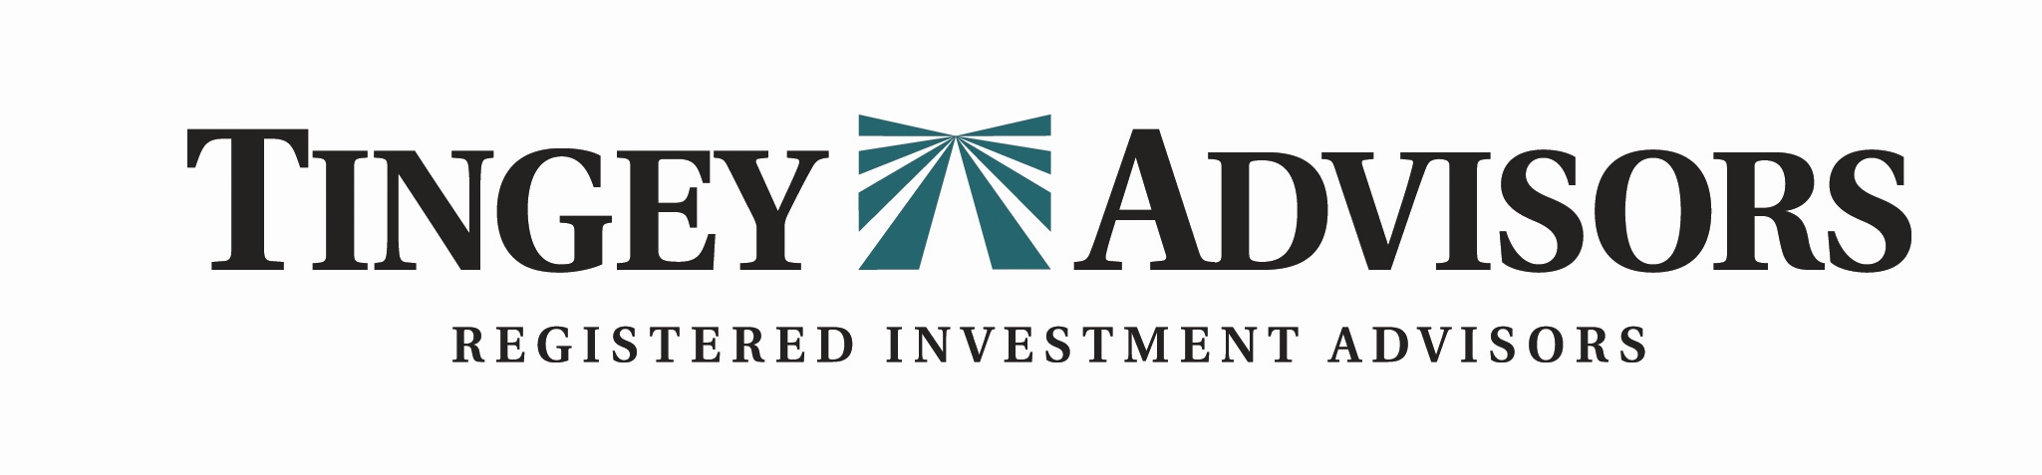

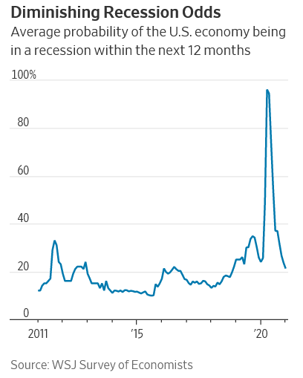
Winter 2021 Newsletter www.tingeyadvisors.com 801-352-8166

Benchmarks
 | 31 Dec 2020 | 30 Sept 2020 | 31 Dec 2019
S&P 500 | 3,756 | 3,363 | 3,231
DJIA | 30,606 | 27,782 | 28,538
NASDAQ | 12,888 | 11,168 | 8,973
6-mo US Treasury Yield | 0.09% | 0.11% | 1.60%
30-yr US Treasury Yield | 1.65% | 1.46% | 2.39%
Prime Rate | 3.25% | 3.25% | 4.75%
Federal Funds Target Rate | 0.00% | 0.00% | 1.50%
30yr Mortgage | 2.88% | 3.03% | 3.30%
Gold – per oz | $1,924 | $1,888 | $1,523
Oil - WTI / bbl | $48 | $40 | $60
Sources for Newsletter: WSJ, Barron’s, Bloomberg, NBER, Blackrock, US Treasury, McKinsey & Co., Bankrate
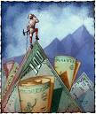

Resilience…cont.
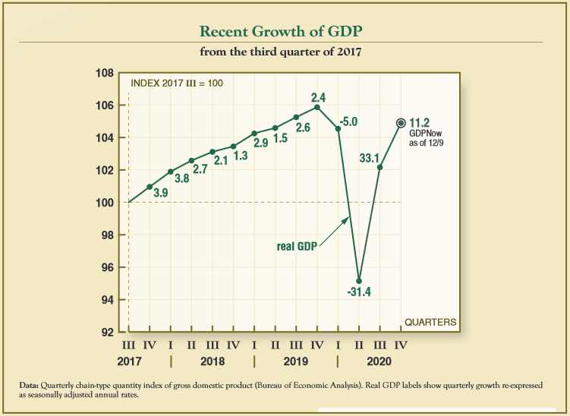
Nine months ago, the country was peering into the coronavirus abyss. It was a given that the public health restrictions caused by the pandemic would usher in severe economic contraction. However, the debate that was less certain centered on what kind of economic recovery would ensue. Would the economy recover quickly in ‘V’ shaped fashion, or would this take years of grinding to get us back to the robust economy we were experiencing in February?
Now, looking back, it is quite remarkable to see the V-shape on paper, and remarkably within the same year. Numbers tell an interesting story but sometimes you just have to stand back and look at a graph and marvel. Only the bravest economist dared make this prediction.

While we are not back to where we started, we are within a pitching wedge of the February economic peak. The improving trends in retail sales, consumer confidence, job creation, inflation, services, and manufacturing industry expansion are not in question. We are certainly not calling victory at this point as there is much that still needs to mend. However, the trend and pace of recovery is a tribute to the strength and resilience of the U.S. economy. We lost a record number of small businesses in the first half of the year and created a record number of new small business in the last half of the year. Only in America!

The unmatched resilience of the U.S. economy is not without help, however. The pandemic ushered in historic monetary and fiscal support by the U.S. government – and we are not done. The U.S. has already spent 2 times more on the corona virus pandemic than the amount of fiscal response to the Great Recession of 2008 according to McKinsey and Company. Certainly, the robust “bounce back” growth we are experiencing will give way to modest growth once we’ve gotten back to where we started.

Resilience has also been seen in the medical and public health community. Healthcare workers have learned much about the virus and treatments have improved. While the expected winter rise in Covid-19 cases has materialized, the death rate from those increased cases have risen at a much slower pace. Vaccine and antiviral therapies went from concept to reality in the fourth quarter, with Pfizer and Moderna beginning distribution of a reliable, tested vaccine a mere nine months since the virus genome was received. It is nothing short of wildly impressive what the medical community has been able to achieve.

Stocks:
After starting the year in freighting fashion, U.S. stocks turned in a third consecutive quarter of dramatic gains, continuing a stock market recovery that few predicted in the spring. The S&P 500, Dow Jones Industrial Average and the Nasdaq Composite set records in the fourth quarter, confounding many investors with their sheer velocity and strength. The S&P 500 and Dow Jones Industrial Average indexes gained 11.6 percent and 10.2 percent, respectively. The NASDAQ Composite surged 15 percent in the fourth quarter and the Russell 2000 small cap index rocketed up 30 percent after being crushed earlier in the year.

The stock market listened to the scientific community that the hopes of a vaccine ending the pandemic has turned into evidence. Never has science delivered so much so fast to a needy world and the stock market applauded the accomplishment.

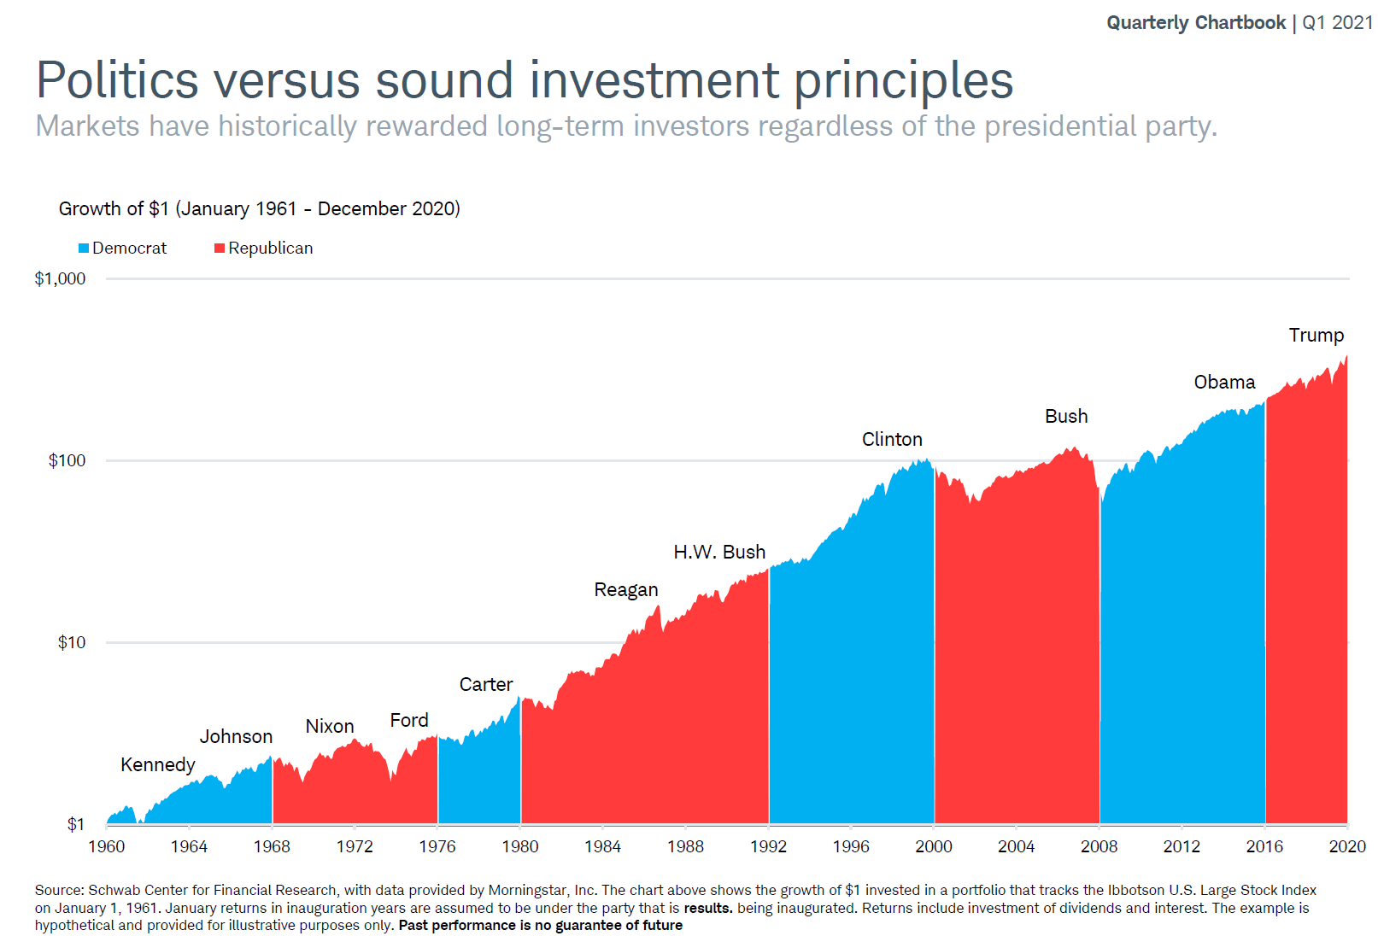
Additionally, the stock market digested a contentious presidential election. Historically the market has shown the ability to digest political changes each cycle. The market goes up under Republican and Democratic administrations and it can go down under both. We anticipate priority changes relative to tax and spending priorities and regulatory changes with a new administration. In the end, the stock market is interested in whether governmental actions are enhancing or restricting economic growth at the margin.
Commodities:
Gold continued its rise, settling for a modest return in the fourth quarter of the year. However, for the full year, the precious metal returned a robust 26% as investors desire for safety drove the price increase. Oil has rebounded from the dramatically wild oil market chaos where oil contracts went negative as investors were paying people to take delivery of crude prices. West Texas Intermediate crude finished the year at $48 per barrel.

Bonds / Interest Rates:
The Federal Reserve’s “do whatever it takes” attitude continued throughout fourth quarter. Federal Reserve Chairman Jay Powell has said repeatedly that he will keep interest rates lower for longer. During the fourth quarter, the Fed Chair followed through on his more emphatic strategy of allowing higher levels of inflation before taking preventative measures. Specifically, Chairman Powell indicated that in economic environments where inflation is below the target and interest rates are essentially zero, they will abandon their prior approach of raising rates preemptively, before inflation reaches 2 percent. The Fed is betting that long term secular trends that have kept inflation at bay will continue into the foreseeable future.

The Treasury market yields curve steepened during the quarter with short term yields remaining anchored at historic lows while the longer-term yields began to rise. The 6-month T-Bill yield finished the year at 0.09% a mere 2 basis points from where it started the quarter. The 30-year Treasury bond rose 19 basis points to finish the year at 1.65%. This steeper yield curve is the bond markets vote of confidence in the vaccine and the resultant improving economic conditions.

Also making a strong vote for more stability or normal economic conditions is the spread between guaranteed U.S. Treasury 10-year notes and non-guaranteed Baa-rated corporate 10-year notes. A large spread indicates turmoil, and a small spread indicates stability. We enjoyed a continued return to stability in the quarter.
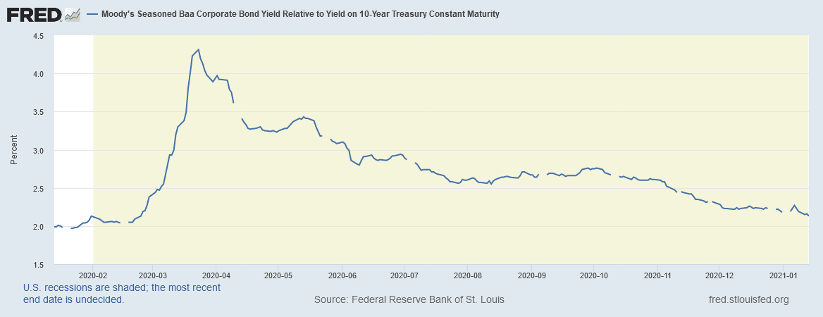

In Summary
As we mentioned previously, we are experiencing one of the most dramatic and traumatic years in our memory. The coronavirus pandemic induced changes to our lifestyle; we experienced public racial protests, rioting, economic uncertainty, stock market volatility and a contentious presidential election. Yet America is winning the economic and healthcare war. As an investor I ask myself why? Why, in the face of all the reasons for failure is America winning. America did not launch this pandemic; it just launched a war against it and is the reason that the world has hope that we will conquer it. Nowhere is there a place that can combine financial and human capital with an innovative culture and spirit to fight such a cause. America is winning because Americans are winners. America is defined by the ingenuity and grit of the underlying citizenry.

Athletic coaches will tell you that talent is not enough, you must have the will to win. Americans understand this and that makes America a great place to invest money. The stock market casts its vote of confidence in this country every day. The market is objective… it owes no lobbyist any favors. It goes up over time and through conflict because it believes in the principles and institutions of this country. It will go down at times for sure, but the long-term trend is unmistakable. This is the place where investments succeed. This is the place where freedom begets innovation which begets better standard of living and lifts people.

There are forces that try to divide for their own political gain. Politicians talk, we wish they would listen. Certainly, we are a more polarized nation, but if Americans want to continue to win, they will reinforce the principles of the country and reinforce the institutions. In the era of social media where everyone has a platform to talk, perhaps this is the time for Americans to listen to each other. We as Americans would do well to watch the not-so-silent vote of confidence the stock market is making in the institutions and principles of this country.

Concern for the health of all our loved ones and your loved ones is on the top of our minds. We pray for you and your family’s health and safety. We also pray that we will emerge from this with a greater commitment to each other, and to the principles that make this country great.

Our investment strategies change with market conditions, but our principles do not. Our long-term optimism remains intact. We recognize that during complex market times, communication is important. It is a privilege working for you. We appreciate your confidence in us, especially during uncertain times.
Tingey Advisors, Inc., founded in 1996, is a registered investment advisor with the Securities and Exchange Commission. If you wish to receive the most recent copy of our ADV, please notify us. We invite you to visit our web page at www.tingeyadvisors.com or call us at (801) 352-8166. Any forward-looking statement mentioned above is subject to risk and uncertainty. All rights reserved, Tingey Advisors, Inc. 2021. Sources for Newsletter: WSJ, Barrons, Bloomberg, NBER, Blackrock, Federal Reserve, JPMorgan Chase

